# CSAC + Youth Heroes Advertising Plan

**Goal:** The community of Millburn Township is aware that there is a place to nominate adult and youth heroes for their service work.

## What to Do:

* Publish news of the new website in ITEM/Patch/TAPInto
* Publish information on Social Media
  + Facebook Group - Happy Millburn
* Engage Residents to Spread the Word & Share via Social Media
* Create an Electronic Flyer for Social Media & News Publishing

## What’s Included in Each Writeup(Who-What-When-Where-Why framework)

* WHO
  + CSAC + Riya Eagle Project
  + Contact Info
    - [**elainebecker@comcast.net**](mailto:elainebecker@comcast.net) **-- CSAC Chair**
    - **Contact me to learn more about Eagle Project--** [**pialityagi@gmail.com**](mailto:pialityagi@gmail.com)**, 603-519-1110**
  + JUST Millburn Residents
* WHAT
  + Young Heroes + Nomination System
  + **Nominate who YOU think is deserving**
  + Basic synopsis of how website works
    - Youth, Adult Nomination + View Heroes Page
    - **All information, without parental permission, is private and confidential for the sole use of the Community Service Award Committee.**
* WHEN
  + Nomination period: Jan 1 - July 31st
  + Award received in Fall
* WHERE
  + Online, website
  + Plaques up in Town Hall
* WHY (inspiration for project)
  + COVID times -- many youth doing work
  + Many people who haven’t been recognized
  + Promoting community service

## FLYERS & LOGOS

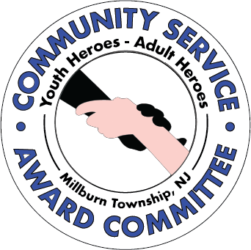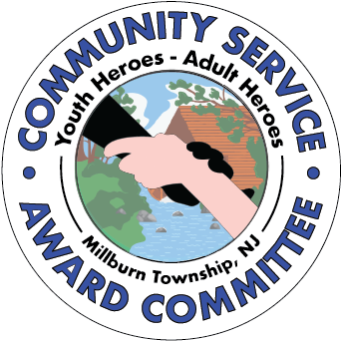

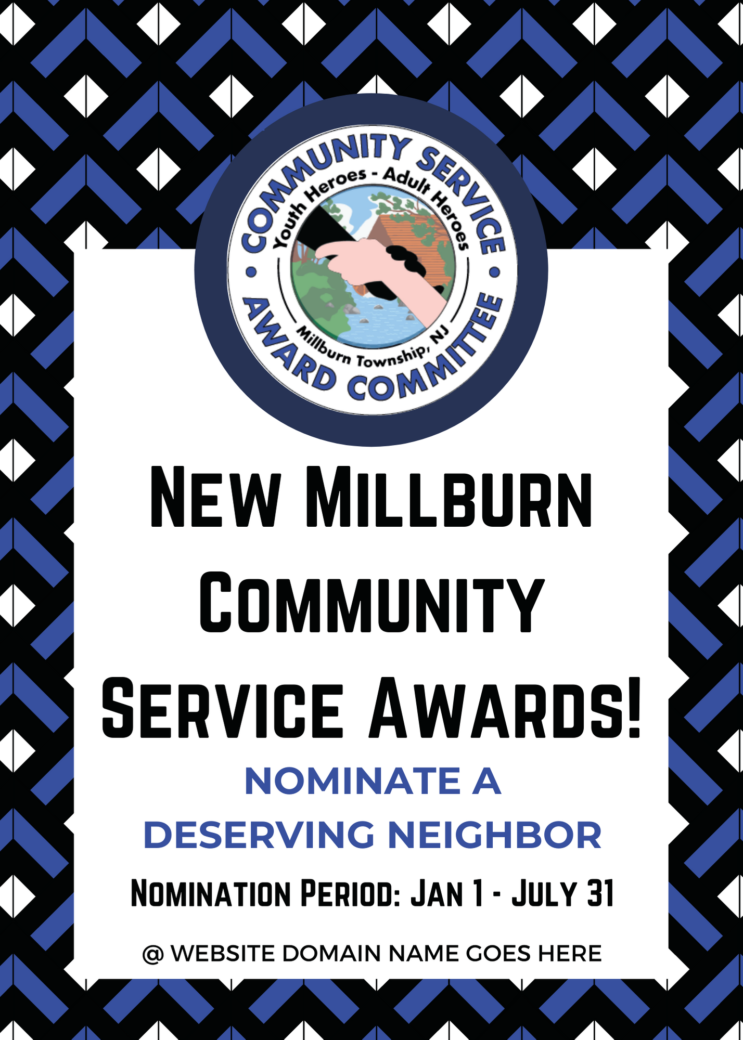

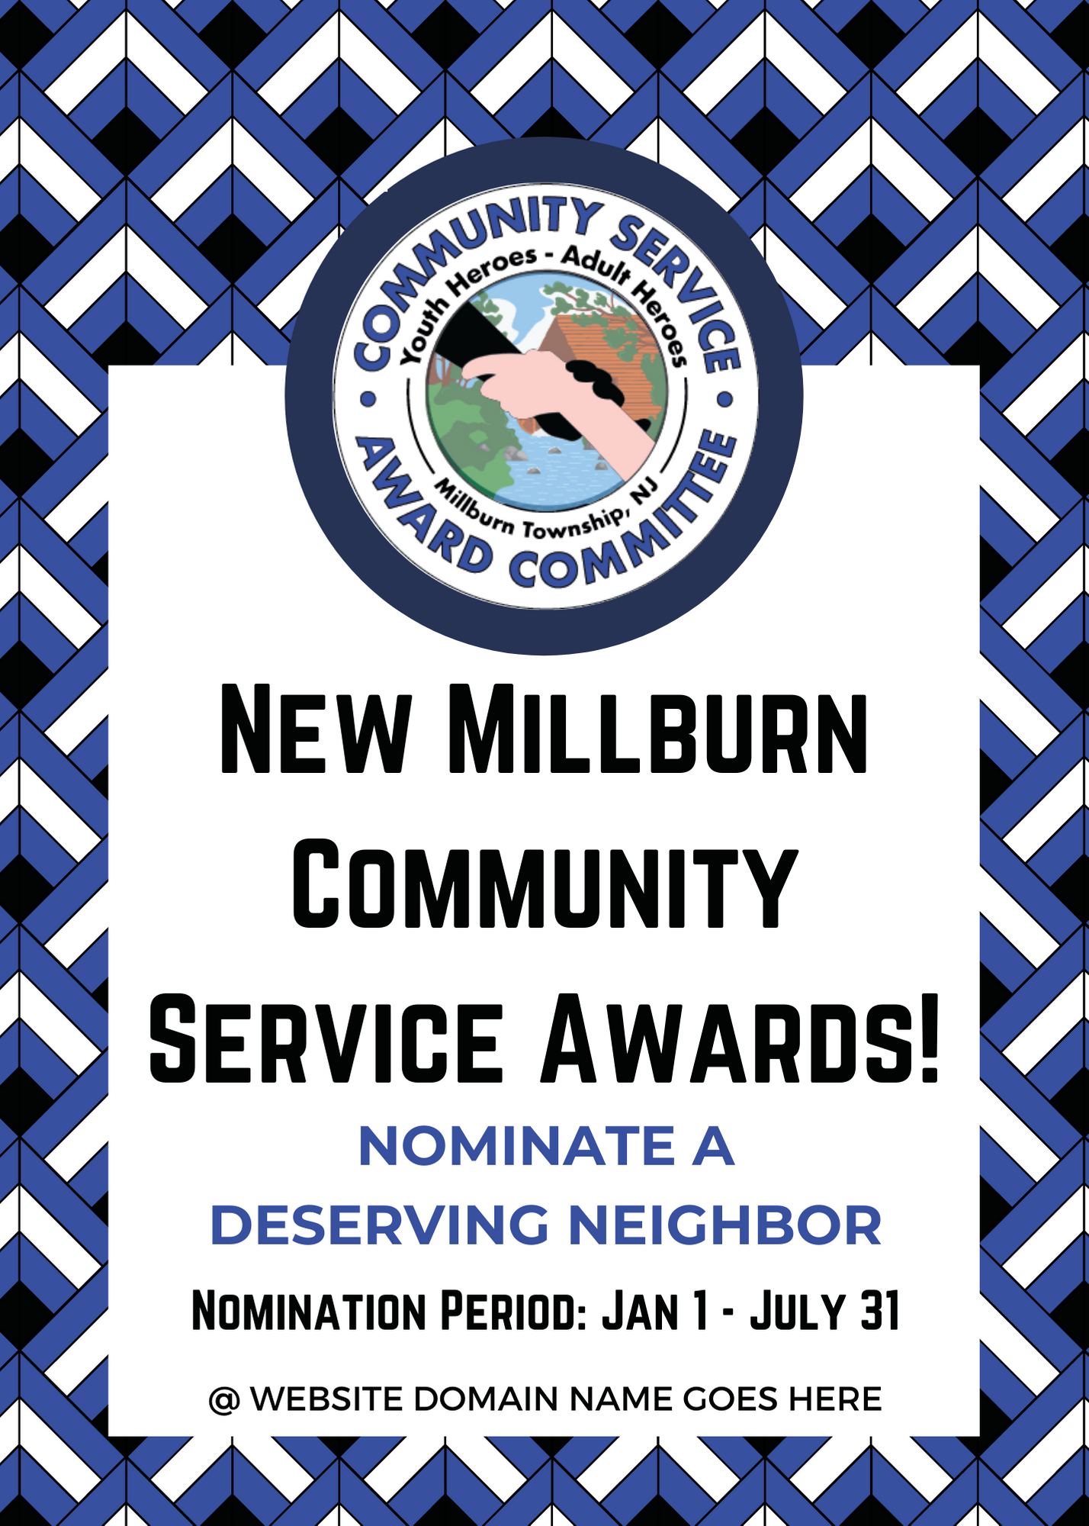

## NEWSPAPER ARTICLE

The New Community Service Award Website is Open for Nominations Starting Jan 1st, 2021

**OR**

**Millburn Short Hills Community Service Award Committee Launches a New Website for Nominations!**

**To nominate, go to: millburntwpcommunityservice.com**

Don’t miss this new and incredible service opportunity! If you know a Millburn resident who has done extraordinary service work for our community, you can now nominate them online to receive the Township’s distinguished community service award.

For almost 30 years, the Township has recognized Millburn residents who have significantly contributed to the community. Scouts BSA Troop 19 Eagle Scout candidate Riya Tyagi has partnered with the Millburn Township Community Service Award Committee (CSAC) to introduce a new youth service award and, through the use of modern technology, automate the nomination process for the Community Service Awards. Her project vision, supported by the CSAC, is to expand the award to recognize deserving youth and adults and to encourage diverse and inclusive nominations.

The Community Service Awards are awarded annually by the CSAC, which aims to “recognize members of the community who have generously given their time and who, through their volunteer activities, have enhanced the quality of life in the Township of Millburn and the community at large.” To learn more, visit the CSAC [webpage](https://www.twp.millburn.nj.us/188/Community-Service-Award-Committee).

Inspiring service and recognizing the efforts of diverse community members, including youth, was very meaningful to Riya, which is why she approached the CSAC for her Eagle Scout Project. Riya says, “Volunteer work starting at a young age has countless positive effects. I have been fortunate to reap these benefits through Scouting and am excited for my Eagle Project as it helps raise awareness about the importance of service, inspires others to take on similar, valuable service opportunities, and allows deserving volunteers to be recognized, which is only more encouraging!”

With the enhanced online nomination process, anyone can nominate a youth or adult candidate for an award on the CSAC’s website by filling out a simple form. Each nomination would then be considered for by the Millburn Township youth and adult Community Service Awards. The nominations are open from January 1 to July 31, and the awards will be announced later in the year.

Take advantage of this opportunity to nominate who you think is making their mark on the town! To learn more about the awards, contact the head of the CSAC at [elainebecker@comcast.net](mailto:elainebecker@comcast.net). For information about the Eagle project, contact Riya at [pialityagi@gmail.com](mailto:pialityagi@gmail.com). Do your part to inspire community service in Millburn and recognize deserving residents.

------------------------

## SOCIAL MEDIA POST

* Flyer
* Please Share the Official Newspaper Article!